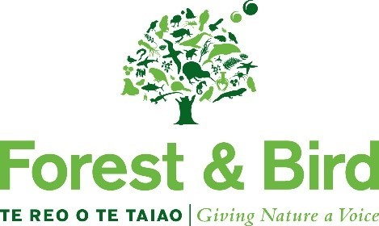

Nomination for Forest & Bird’s Branch Award

* Please complete all sections of the nomination form
* Please provide as much supporting information as possible
* All nominations must be approved by the branch committee and submitted either via the official F&B branch email or via mail

|  |
| --- |
| **Selection Criteria *(Please note the nominator may not be a relative of the nominee):*** |
| The aim of this award is to recognise a branch that have been actively protecting and restoring nature in their region, on land or sea, and/or successfully engaging their local community with the issues facing Forest & Bird. This award aims to recognise the overall contribution to the natural environment that a branch has had in their region. We can recognise a single achievement, but the purpose of this award is to recognise the breadth of activity that a branch needs to undertake and the variety of skills that they need apply to successfully protect and restore New Zealand’s natural environment.  The winner(s) of Forest & Bird’s Branch Award *may* have:   * Successfully submitted to the city, district or regional council. * Successfully worked or advocated to DOC. * Ran a great KCC group – one that grew or gained some publicity. * ***Inspired*** others to contribute. * Had a successful year in a restoration project. * Set up a new project.   *This Award will be presented by a Board member at a regional meeting, island gathering or local branch meeting; but announced at the annual conference.*  *It would be preferable if the winning branch is able to attend the Sanderson Memorial Dinner (June 2025) which will be held after the South Island Gathering.* |

|  |  |  |
| --- | --- | --- |
| **Nominator Details** | | |
| **Nominator Name:** |  | |
| **Contact Name (if different to above):** |  | |
| **Phone:** | **Home:**  **Work:** | **Mobile Phone Number:** |
| **Address:** |  | |
| **Email:** |  | |

|  |  |  |
| --- | --- | --- |
| **Nominee Branch Details** | | |
| **Branch:** |  | |
| **Branch Chair / Secretary:** |  | |
| **Branch Chair / Secretary contact details:** | **Home:**  **Work:** | **Mobile Phone Number:** |
|  | **Email:** | |

|  |
| --- |
| **Reasons Supporting Nomination** |
| Please describe the activities that show the Branch have met the selection criteria. Where possible provide supporting news clippings, success stories, facts and figures etc. |

*Please use additional pages if* *necessary.*

|  |  |  |
| --- | --- | --- |
| **Regional Conservation Manager (who can be contacted to support the nomination)** | | |
| **Regional Conservation Manager Name:** |  | |
| **Phone:** | **Home:**  **Work:** | **Mobile Phone Number:** |
| **Address:** |  | |
| **Email:** |  | |

Before submitting the nomination form, please check that:

O All sections have been completed

O All supporting documentation is attached

Incomplete forms and/or nominations submitted directly and not through the committee will be returned.

Once complete, please send all documentation to:

[c.mangan@forestandbird.org.nz](mailto:c.mangan@forestandbird.org.nz)

or

Claire Mangan

EA & Board Administrator

Forest & Bird

PO Box 631

Wellington 6140

The closing date for nominations is **Friday 28 March 2025.**

|  |  |  |
| --- | --- | --- |
| **OFFICE USE ONLY** | | |
| Nomination received: | Date: | Initials: |
| Acknowledgement Sent: | Date: | Initials: |